**Green Society Public School**

**D-10**

**Ratnanagar-7, Sauraha, Chitwan**

**Second Terminal Examination-2082**

**Class: One Time: - 1 hr. F.M.: 25**

**Sub: English II**

|  |
| --- |
| **Name: Roll No.: Sec.:** |
| **­­­­­­­­­­­­ ________________ ______________ OBT.MARKS:**  **INVIGILATOR EXAMINER** |

**Q.no.1] Write the names of the pictures using ‘a’ or ‘an’. (4×1=4)**

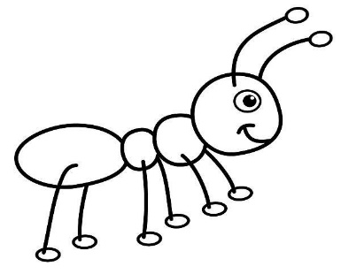a) b)

________________ _________________

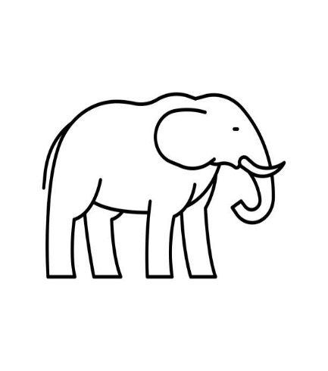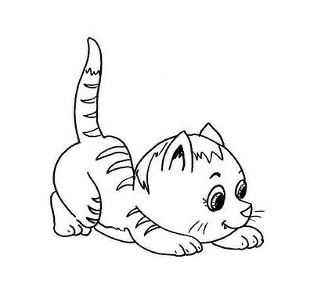c) d)

____________________ __________________

**Q.No.2] Change these singular nouns into plural nouns. (4×1=4)**

a) pen = _________

b) bird = _________

c) mango = ____________

d) watch = ___________

**Q.No.3] Rewrite the following sentences correctly. (4×1=4)**

Example: Hari are my best friend.

= Hari is my best friend.

1. I is a good boy.

=____________________________

1. They am reading now.

=______________________________

1. She are a nurse.

=_____________________________

1. We is helping them.

=_____________________________

**Q.No.4] Fill in the blanks with suitable prepositions. (5×1=5)**

**(by, in, on, between, under)**

a) Fish live _______ water.

b) The mouse is _____________ the chairs.

c) The dog is__________ the table.

d) I go to school ________ bus.

e) The boy is___________ the tree.

**Q.No.5] Tick(V) the correct verb. (4×1=4)**

a) They___________ (help / helps) us.

b) I __________ (eat / eats) an apple.

c) She___________ (dance / dances) very well.

d) He _________ (give / gives) me his book.

**Q.No.6] Answer the given questions. (2×2=4)**

a) What does singular mean?

=___________________________________________

b) Where do we use ‘are’ be verb?

=____________________________________________

**The End**